**STEPS FOR RAISING HCL NON-STANADRD LAPTOP REQUEST (ONLY FOR OFFSHORE USERS)**

1. Please raise Service Xchange request as per below steps.

* **Path** - MYHCL – ServiceXchange - Laptop Allocation in Hardware Requests – Order Now
* **Reason for Request** – On Call Support
* **Are you placing this Order against Bulk Request** - Yes
* **SX Bulk Purchase – Laptop Order no** - ORD000001580925
* in **Project** **Code** – Please take your current Project code (Use Wawa project code preferably).
* In **Complete Delivery Address** section**:**
  + Mention your address with PINCODE
  + Mention your mobile number
  + **Noida users** - Mention PR No - PR101744
  + **Bangalore/Hyderabad/Chennai users** – Mention PR No - PR101742
* In **Comments** section:
  + Mention - IBM ThinkPad model P52s, Disk Space:  500GB SSD, Memory:  32GB, Processor:  i7, RAM- 32 GB

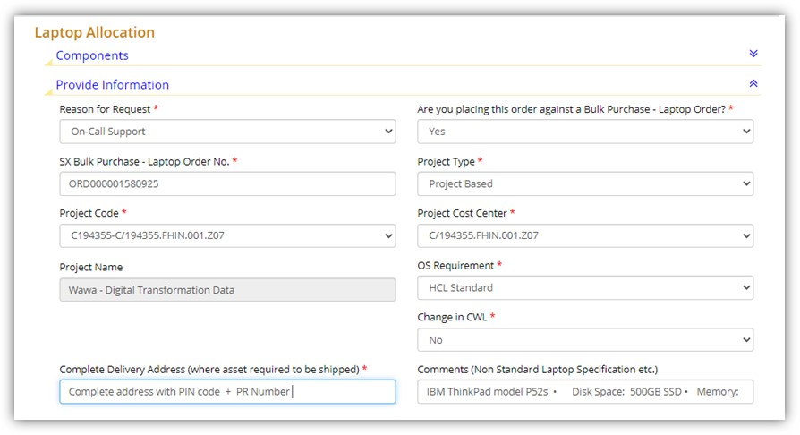

1. Once the request is raised please share following details with Sharad Vaish (51560954) and Sandeep Goel (51475881).
   1. Name
   2. Employee ID
   3. Order Number (from Service Xchange request)
   4. Complete address (where non-standard laptop to be shipped)
2. Details will be shared with respective teams for shipping the laptops.